**Density-Based Stream Network Extraction from Digital Elevation Models**

Mehran Ghandehari, Barbara P. Buttenfield

Department of Geography, University of Colorado-Boulder, CO, USA

{[mehran.ghandehari , Babs} @ colorado.edu](mailto:mehran.ghandehari@colorado.edu)

Water is a very important natural resource, and it is mandatory that the surface water datasets used for topographic mapping, hydrological modeling, and water management contain a complete and accurate representation of water channels. Digital Elevation Models (DEMs) are widely used for stream network extraction. DEM-based methods track the simulated flow of water to calculate flow direction and flow accumulation (Tarboton et al, 1991). The conventional practice for delineating a stream network from a DEM is to define a cutoff threshold for flow accumulation. The most common way to determine a cutoff threshold is by trial and error, which can be time consuming, inconsistent from one location to another, and possibly erroneous (if an inappropriate threshold value is selected).

In this research, an automated workflow extracts a sequence of stream networks from a flow accumulation matrix using a progression of threshold values. Then, to find the optimum threshold, the extracted stream networks are compared to a benchmark data source (here, the 1:24,000 High Resolution NHD). Comparison is computed using a conflation ratio between matching stream channel lengths to matches and mismatches (here, the coefficient of line correspondence (CLC) is used, which estimates how well two sets of line features match (Stanislawski et al, 2010)), as well as an analysis of the spatial distribution of mismatches in the stream network (e.g., first order tributaries, larger order channels, or throughout the network). Although this basic workflow runs successfully, the final extracted stream networks do not account for local differences in stream density (Fig. 1), which have been shown in previous research to be cartographically and hydrologically important (Buttenfield et al, 2010). Local density variations are important to hydrologic analysis, and using one single threshold value for extracting stream networks for region characterized by varying stream channel densities can distort hydrological modeling results in subsequent flow or length computations.

This research proposes a new method to determine the best thresholds within previously established channel density partitions of the hydrological unit of interest. To obtain the best threshold, flow direction and flow accumulation are first calculated for the whole study area. Next, the study area is categorized on the basis of stream network density that is calculated from the vector NHD. The selection of an optimal flow accumulation threshold value iterates through a progression of values selected through a binary search. Results are compared to the benchmark data set, until a threshold value achieves the stream channel that is closest to the benchmark data set (Fig. 2). The results illustrate that the proposed method provides a more geographically and hydrologically valid database representation of elevation-derived stream networks.

Buttenfield, B.P., Stanislawski, L.V. and Brewer, C.A., 2010, Multiscale Representations of Water: Tailoring Generalization Sequences to Specific Physiographic Regimes. \**GIScience 2010 Short Paper Proceedings*\*, Zurich, Switzerland, September.

Stanislawski, L.V., Buttenfield, B.P. and Samaranayake, V.A., 2010, Automated Metric Assessment of Hydrographic Feature Generalization Through Bootstrapping, \**Proceedings, 13th International Cartographic Association Symposium on Multiple Representations and Map Generalization*\*, Zurich Switzerland, September.

Tarboton, D.G., Bras, R.L., and Rodriguez-Iturbe, I., 1991, On the extraction of channel networks from digital elevation data. \**Hydrologic Processes*\*, v. 5(1), p. 81-100.

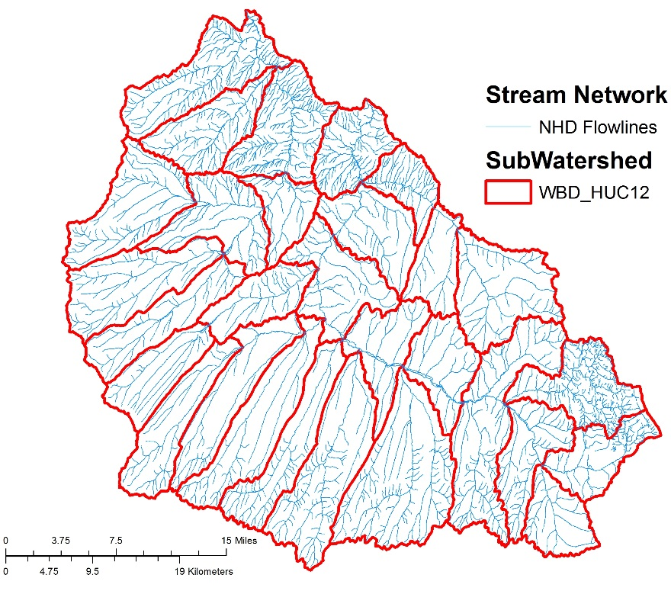

**Fig 1.** The Piceance-Yellow River subbasin (HUC 14050006), located in northwestern Colorado. This region is defined by its dry climate and mountainous terrain, with a mean elevation of 2202 m and an average slope of 26.7%. Subwatersheds (HUC 12s) in the sub-basin are identified. Choosing one threshold for each subwatershed leads to extracted stream networks that do not account for local density variations.

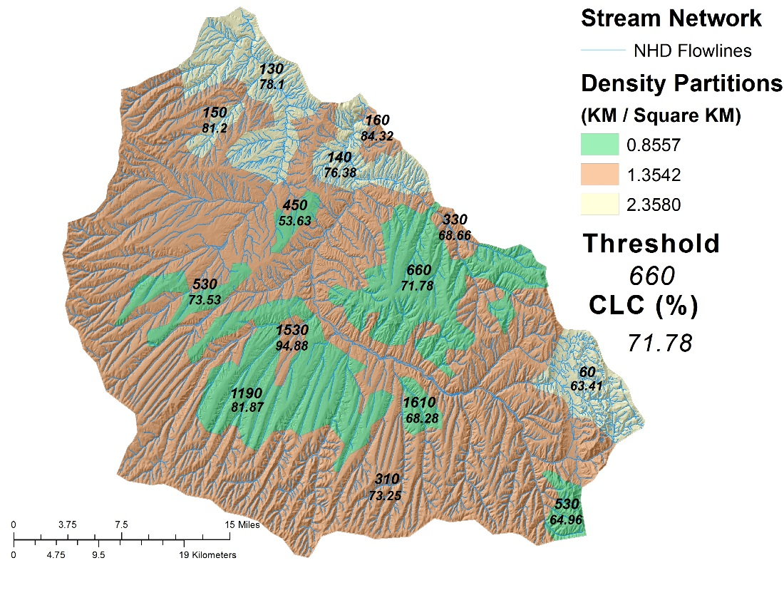

**Fig 2.** This subbasin has three density partitions that are applied to the fourteen separate polygons within the HUC 12 regions. The optimum threshold and its CLC is identified for each density polygon.